Assignment 3

Experiment 1:
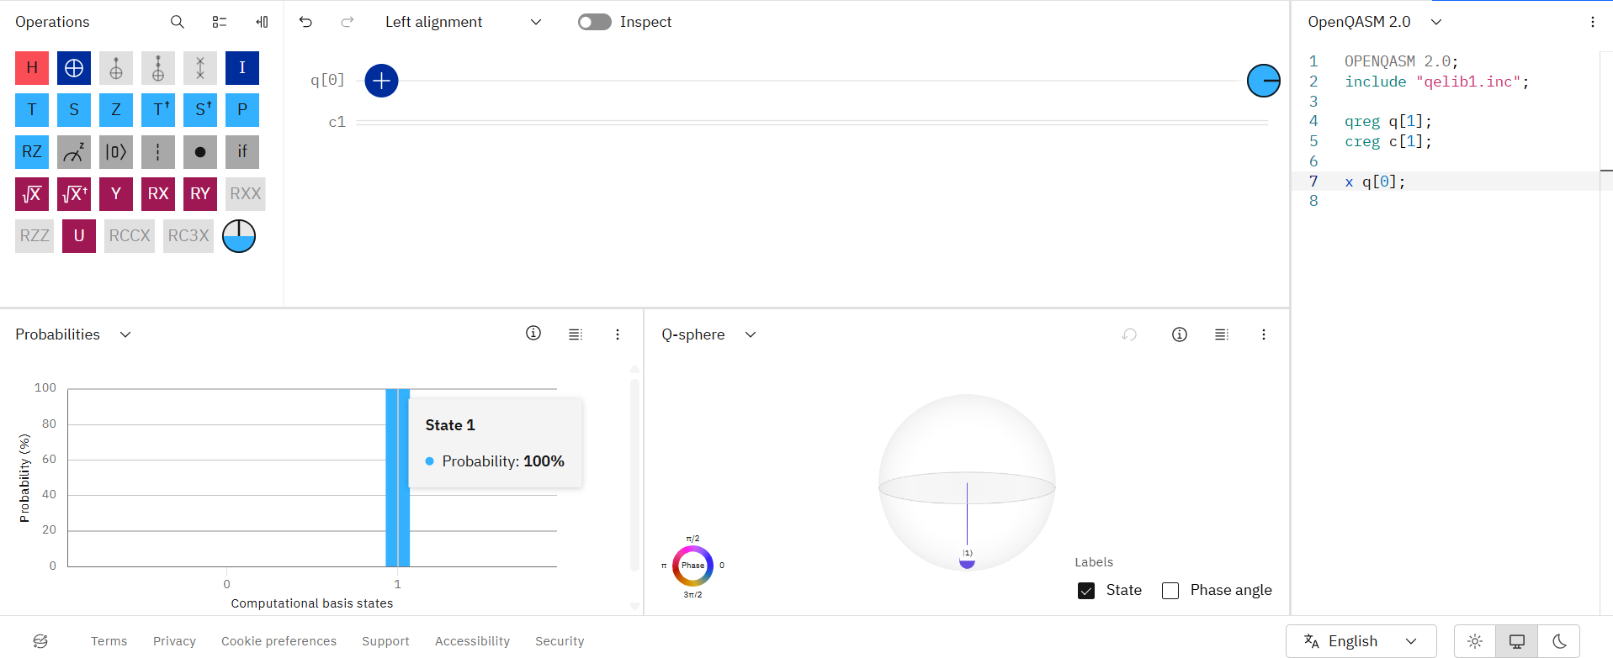
Initial state |0⟩ + Pauli-X
OPENQASM 2.0;
include "qelib1.inc";
qreg q[1];
creg c[1];
x q[0];
measure q[0] -> c[0];

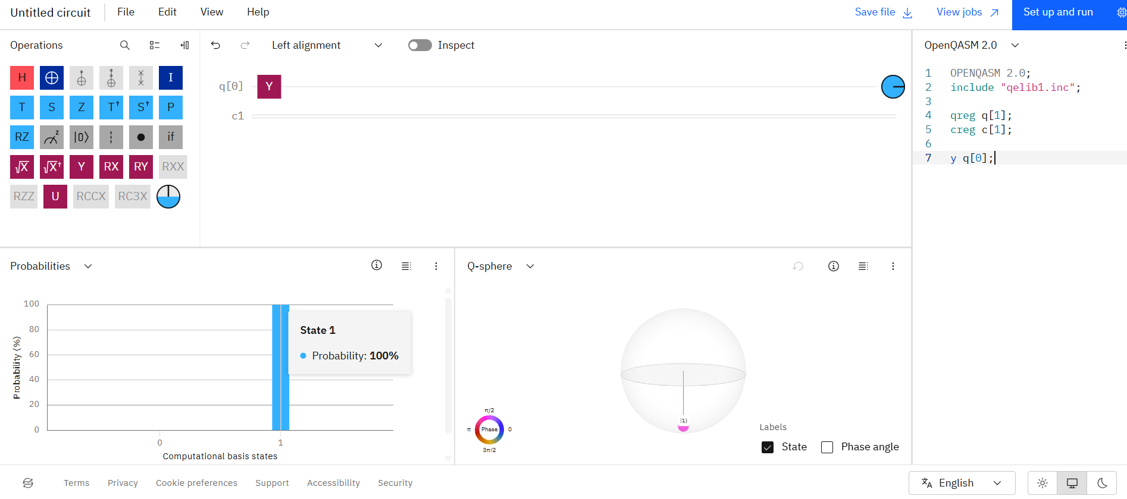

Initial state |0⟩ + Pauli-Y
OPENQASM 2.0;
include "qelib1.inc";
qreg q[1];
creg c[1];
y q[0];
measure q[0] -> c[0];
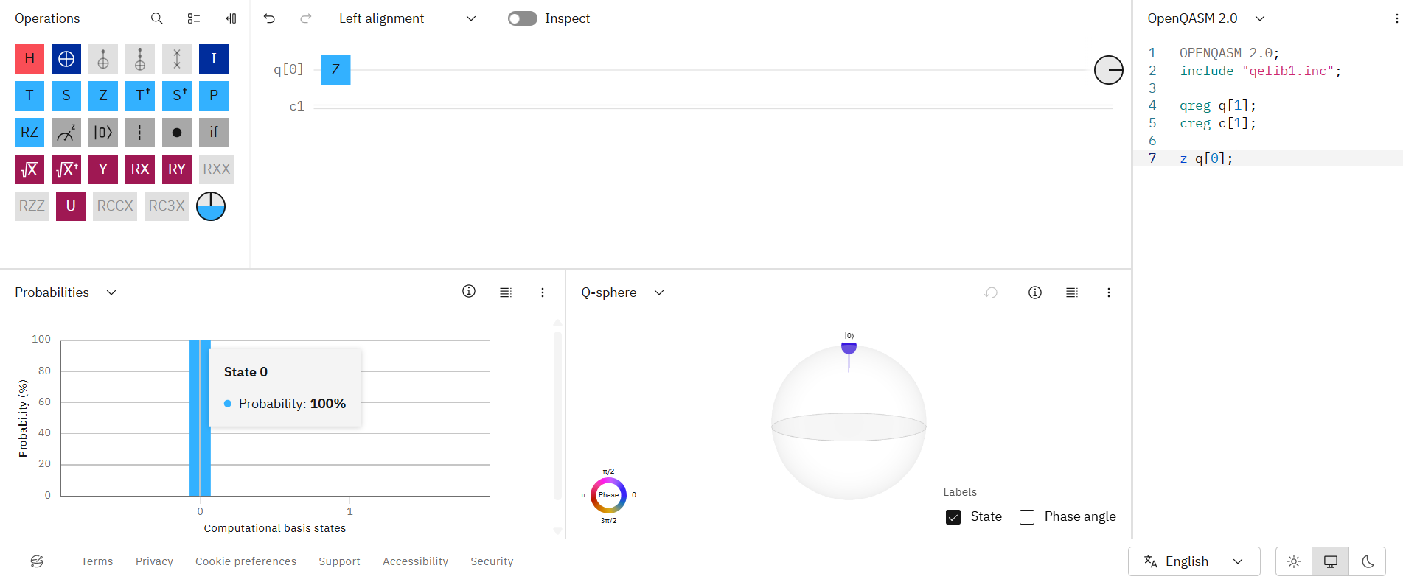

Initial state |0⟩ + Pauli-Z
OPENQASM 2.0;
include "qelib1.inc";
qreg q[1];
creg c[1];
z q[0];
measure q[0] -> c[0];

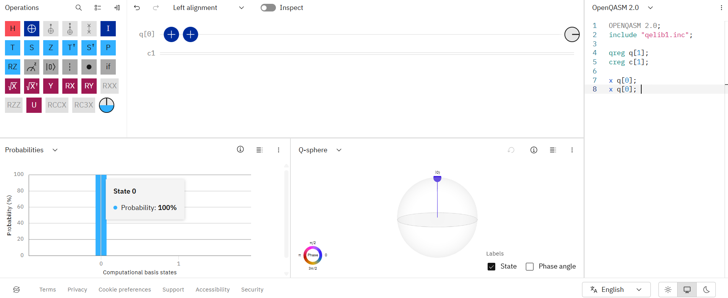
Initial state |1⟩ + Pauli-X
OPENQASM 2.0;
include "qelib1.inc";
qreg q[1];
creg c[1];
x q[0];
x q[0];
measure q[0] -> c[0];

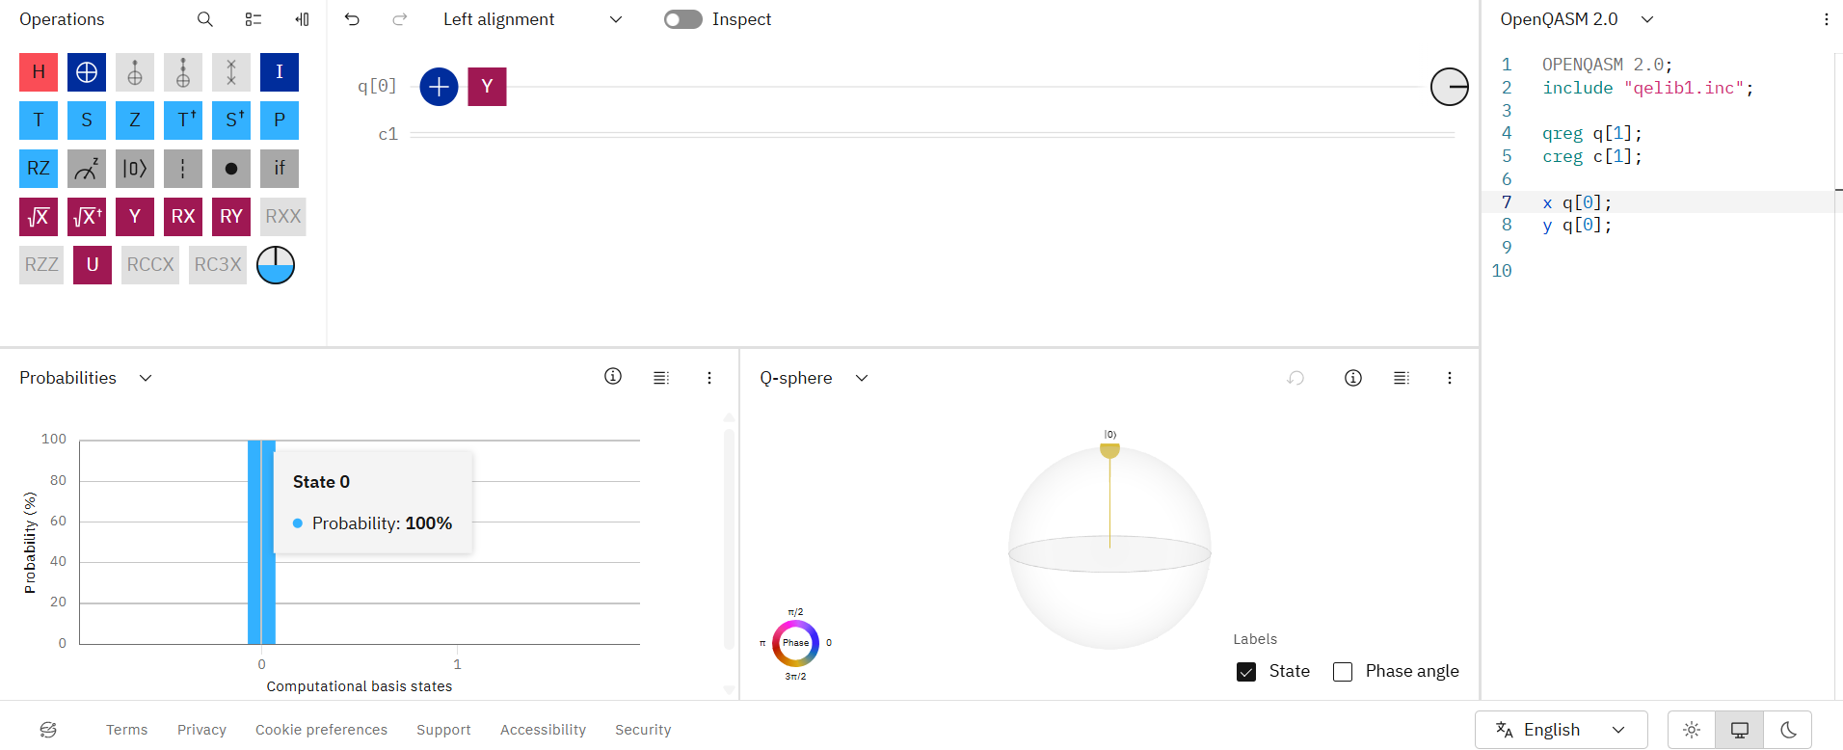
Initial state |1⟩ + Pauli-Y
OPENQASM 2.0;
include "qelib1.inc";
qreg q[1];
creg c[1];
x q[0];
y q[0];
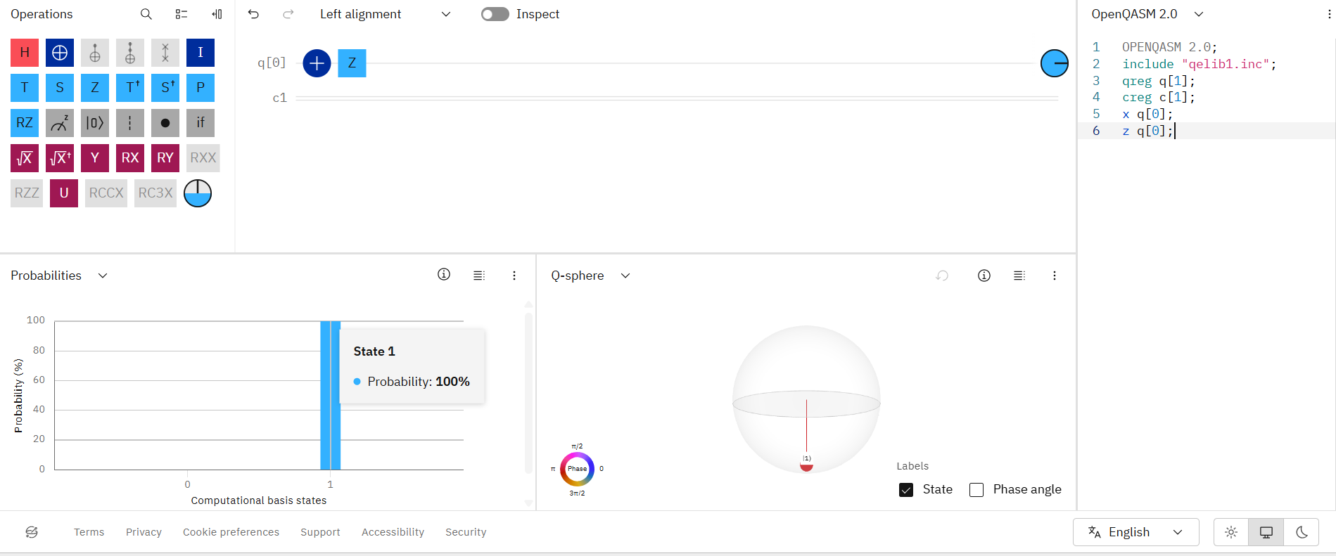
Initial state |1⟩ + Pauli-Z
OPENQASM 2.0;
include "qelib1.inc";
qreg q[1];
creg c[1];
x q[0];
z q[0];

Experiment 2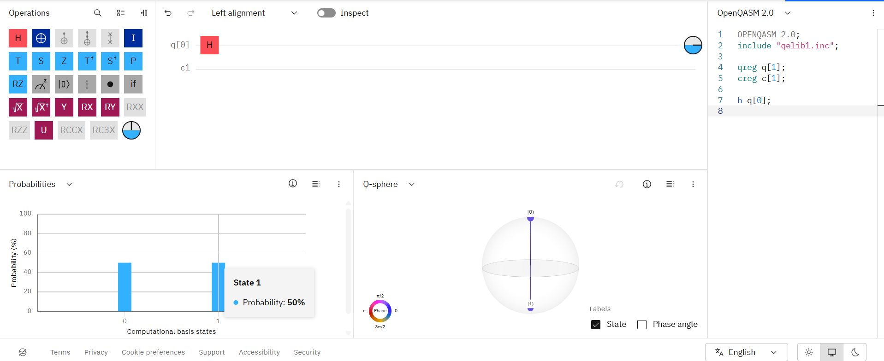
OPENQASM 2.0;
include "qelib1.inc";
qreg q[1];
creg c[1];
h q[0];

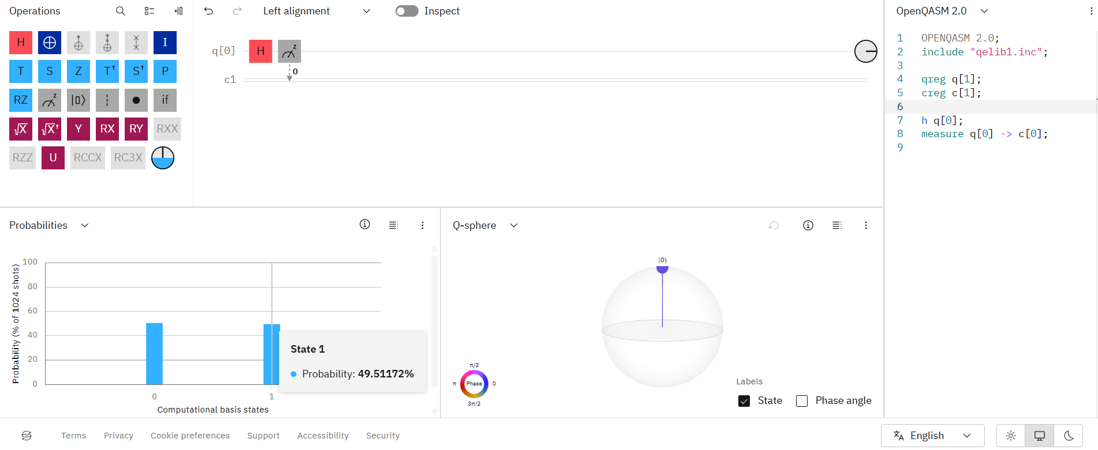
OPENQASM 2.0;
include "qelib1.inc";
qreg q[1];
creg c[1];
h q[0];
measure q[0] -> c[0];

Experiment 3:
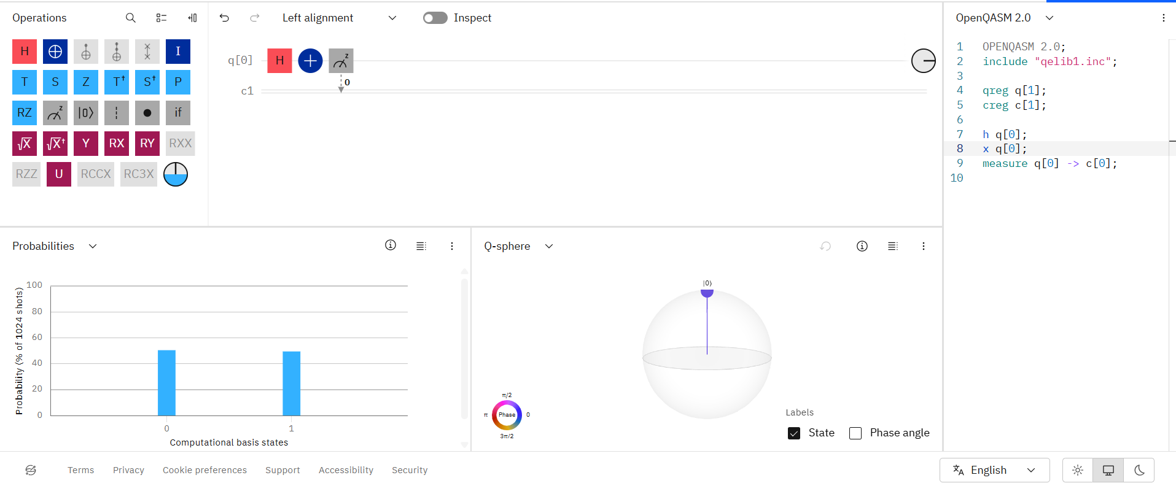
OPENQASM 2.0;
include "qelib1.inc";
qreg q[1];
creg c[1];
h q[0];
x q[0];
measure q[0] -> c[0];

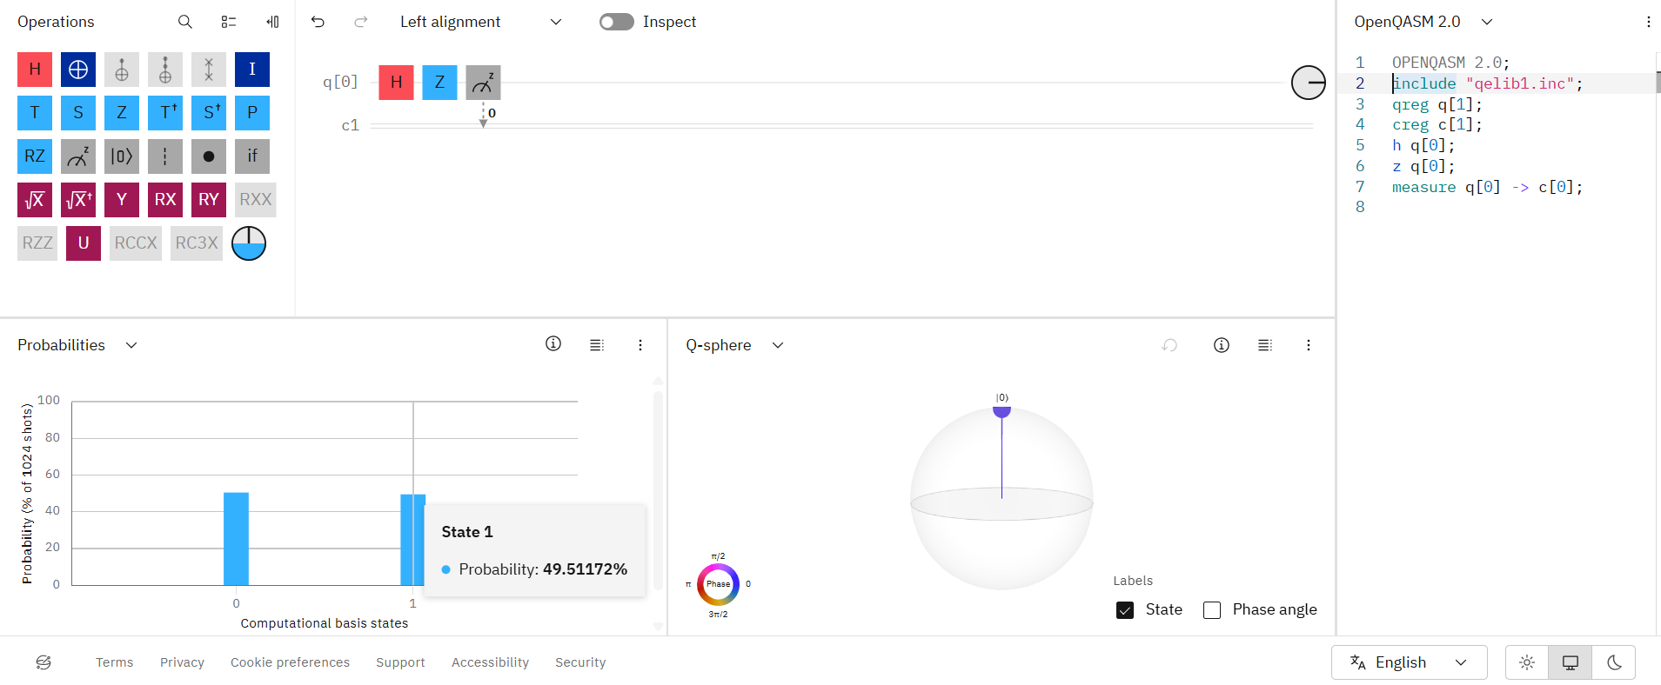
OPENQASM 2.0;
include "qelib1.inc";
qreg q[1];
creg c[1];
h q[0];
z q[0];
measure q[0] -> c[0];

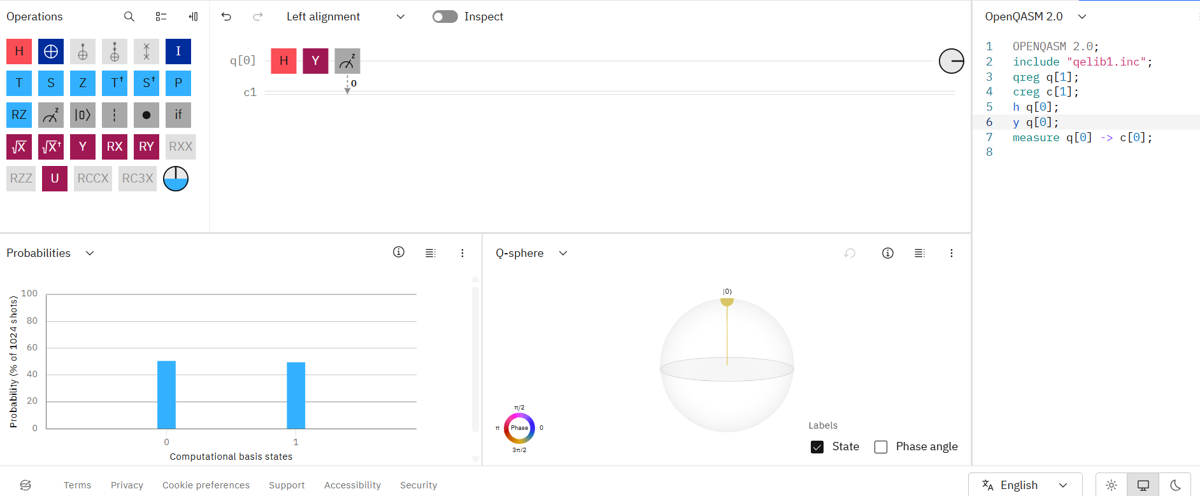
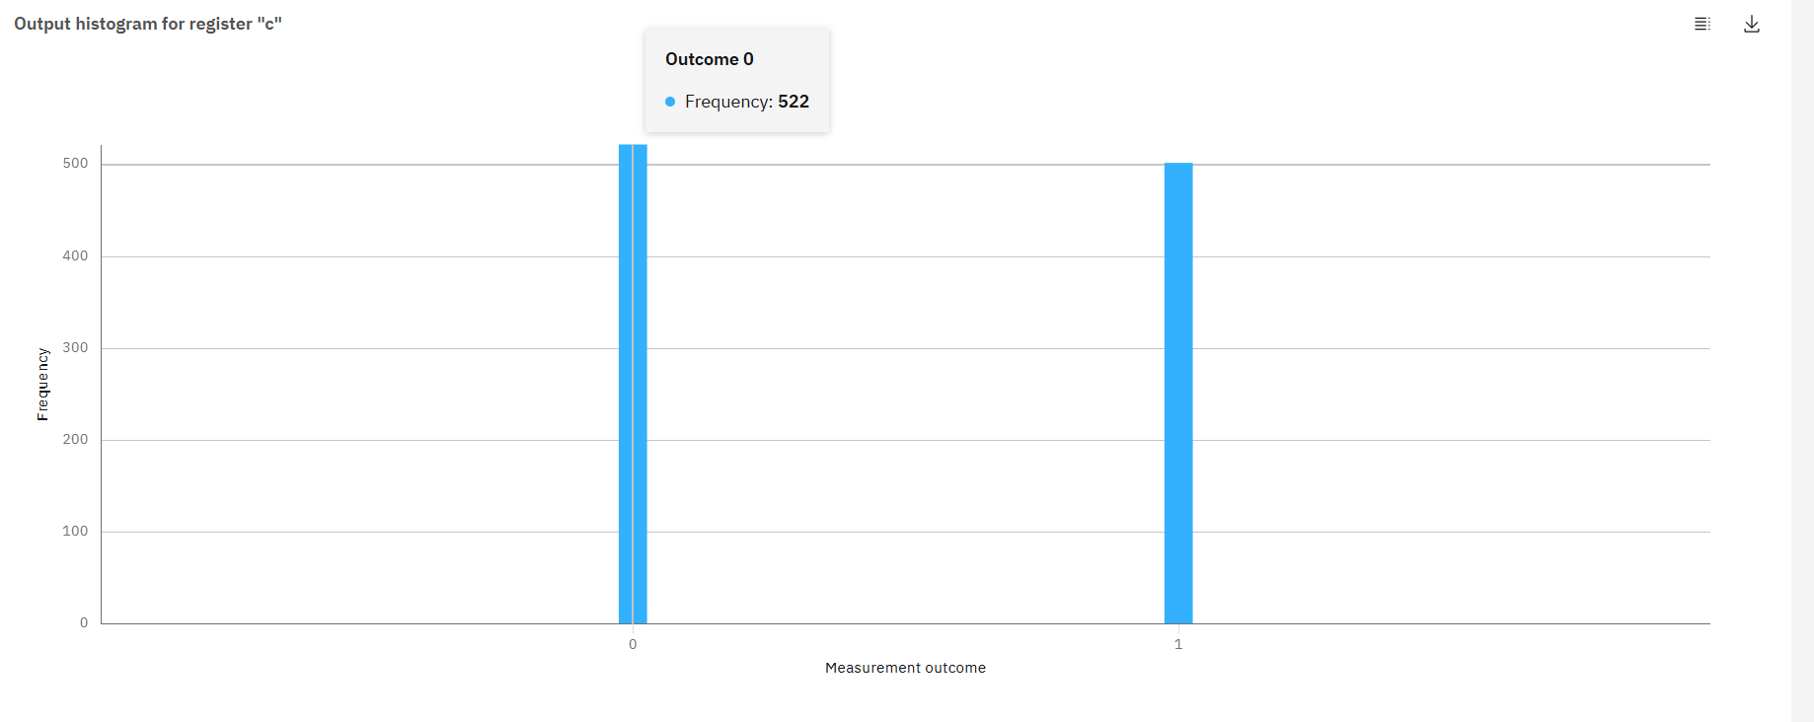OPENQASM 2.0;
include "qelib1.inc";
qreg q[1];
creg c[1];
h q[0];
y q[0];
measure q[0] -> c[0];

Experiment 4:
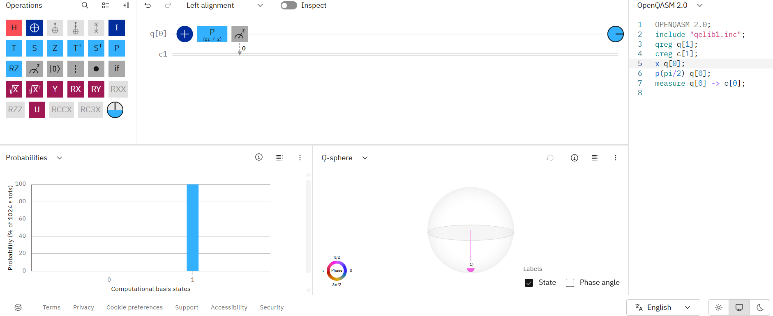 OPENQASM 2.0;
include "qelib1.inc";
qreg q[1];
creg c[1];
x q[0];
p(pi/2) q[0];
measure q[0] -> c[0];
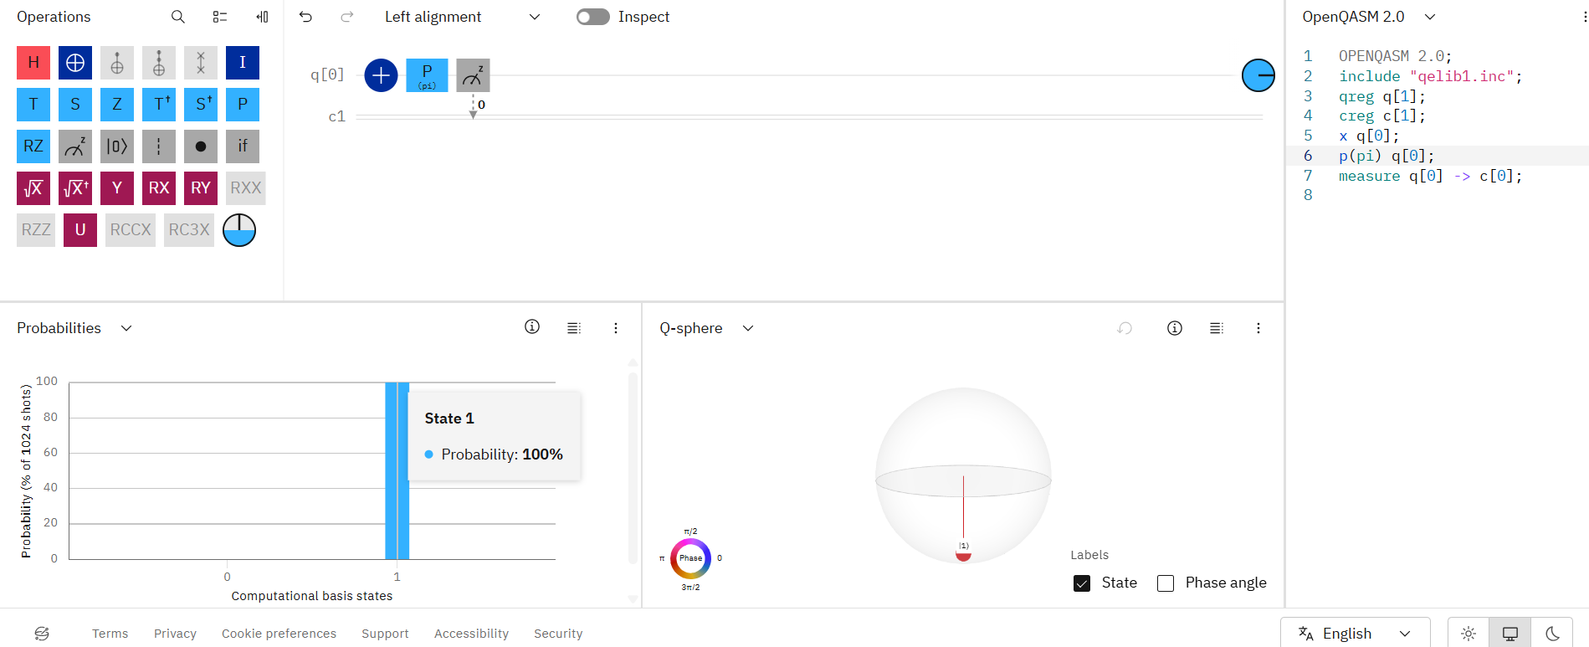

OPENQASM 2.0;
include "qelib1.inc";
qreg q[1];
creg c[1];
x q[0];
p(pi) q[0];
measure q[0] -> c[0];
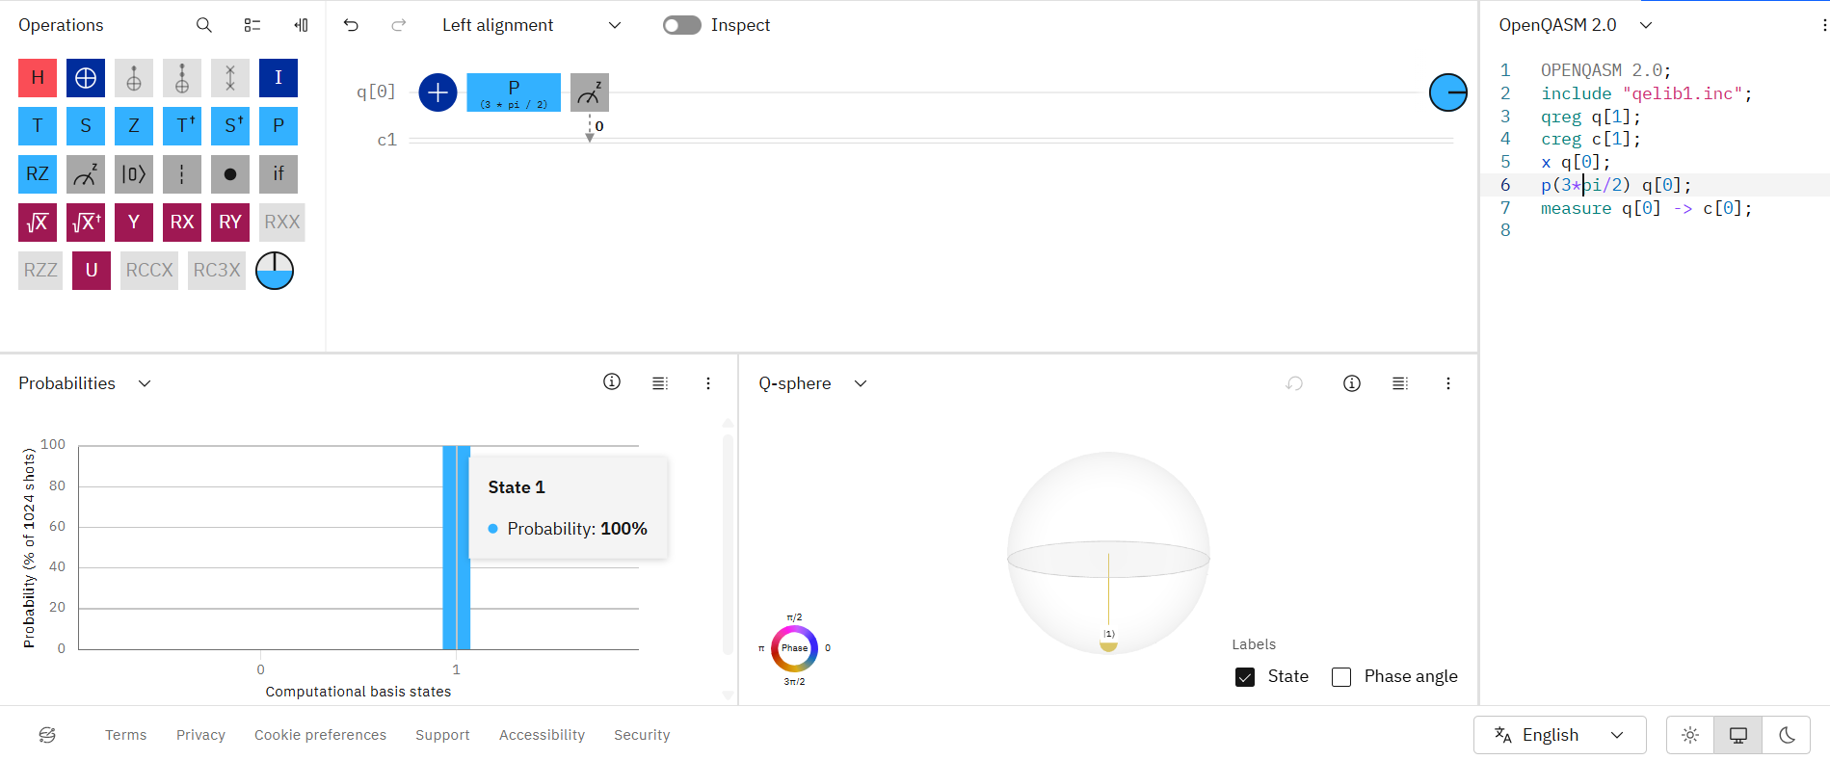
OPENQASM 2.0;
include "qelib1.inc";
qreg q[1];
creg c[1];
x q[0];
p(3*pi/2) q[0];
measure q[0] -> c[0];

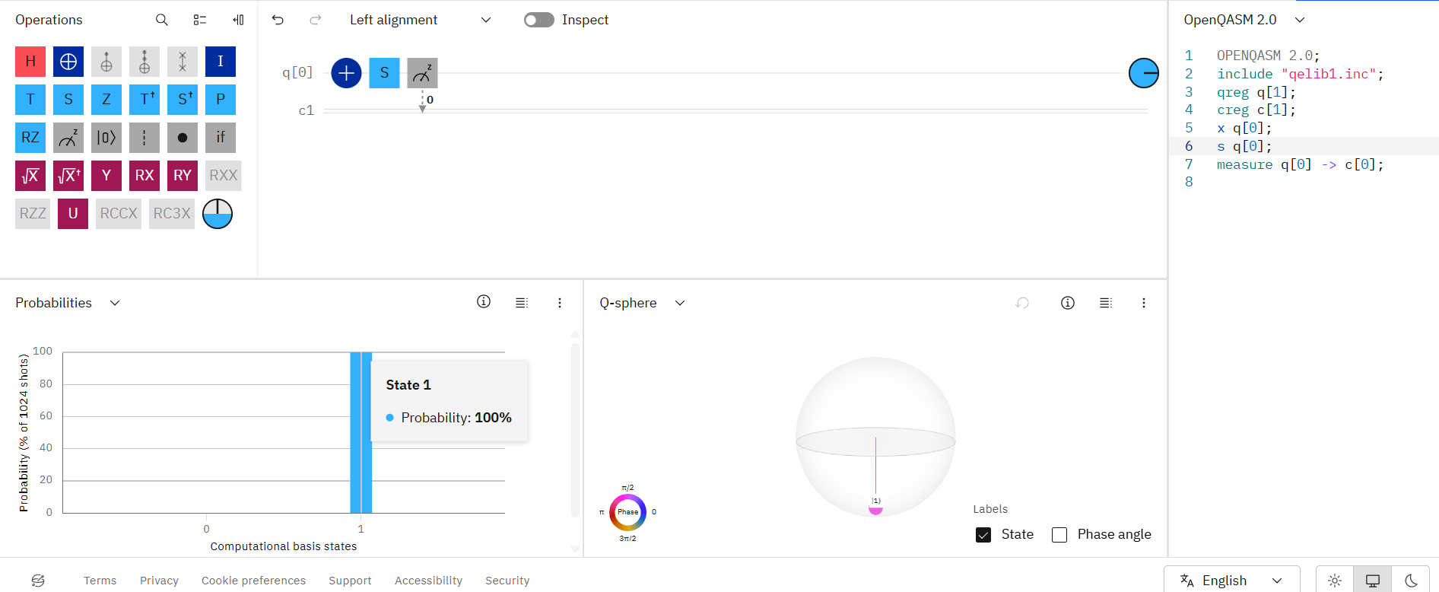 OPENQASM 2.0;
include "qelib1.inc";
qreg q[1];
creg c[1];
x q[0];
s q[0];
measure q[0] -> c[0];

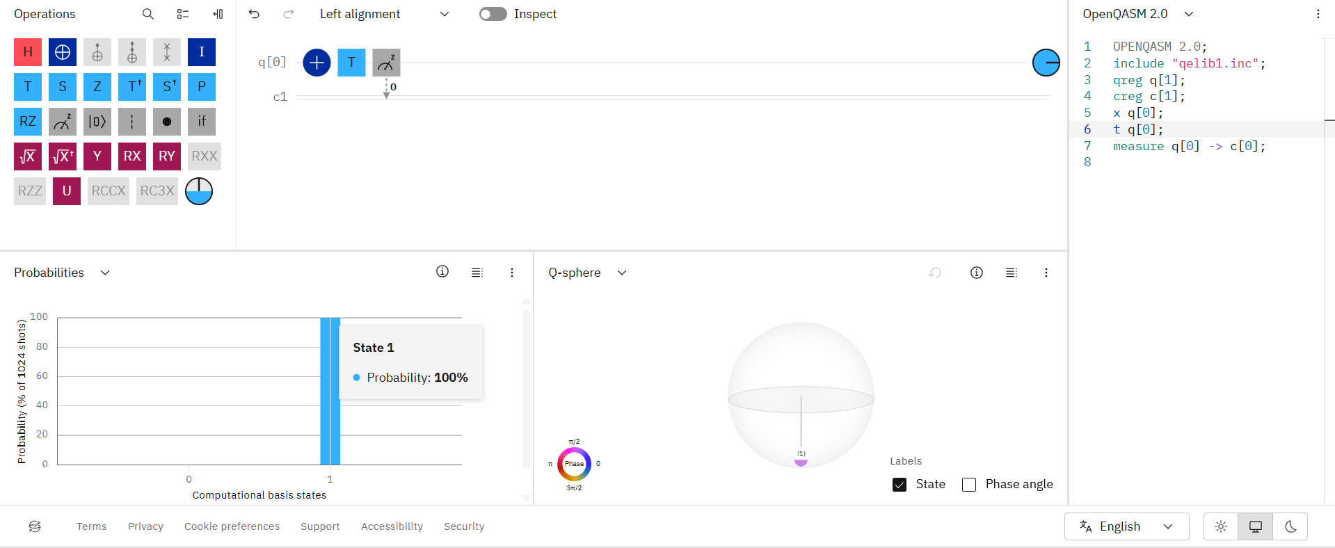 OPENQASM 2.0;
include "qelib1.inc";
qreg q[1];
creg c[1];
x q[0];
t q[0];
measure q[0] -> c[0];

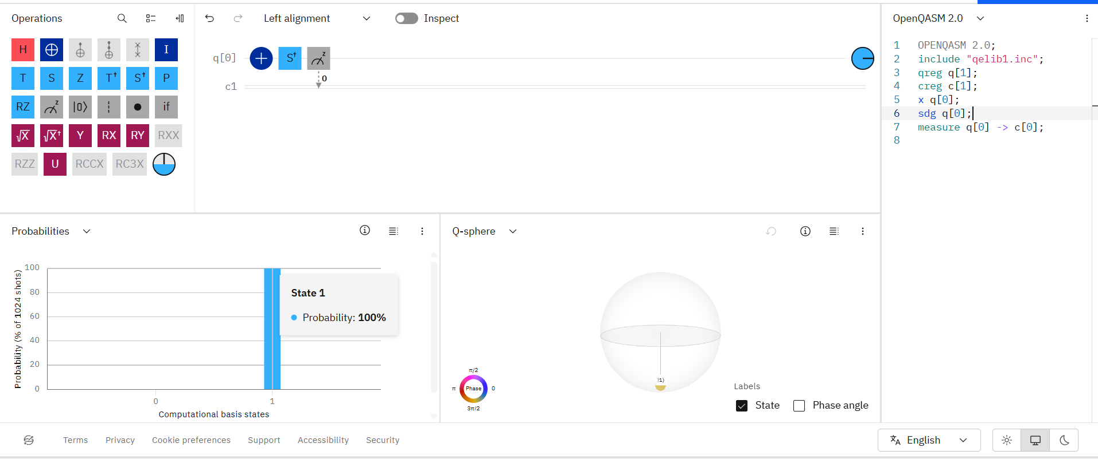 OPENQASM 2.0;
include "qelib1.inc";
qreg q[1];
creg c[1];
x q[0];
sdg q[0];
measure q[0] -> c[0];

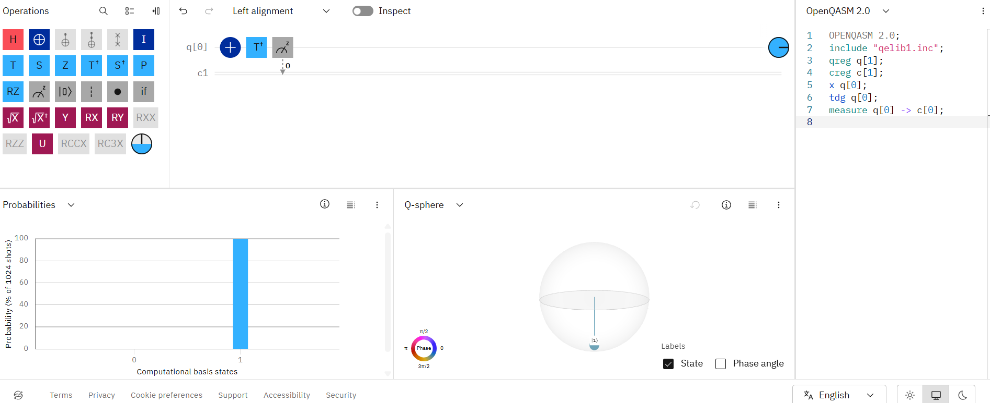 OPENQASM 2.0;
include "qelib1.inc";
qreg q[1];
creg c[1];
x q[0];
tdg q[0];
measure q[0] -> c[0];

Experiment 5:
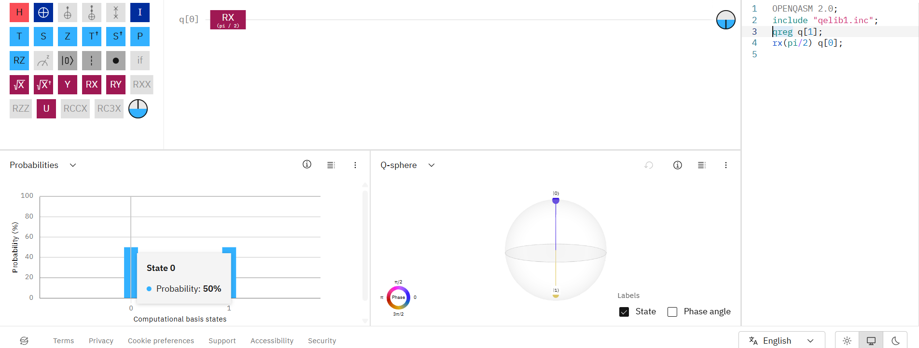 OPENQASM 2.0;
include "qelib1.inc";
qreg q[1];
rx(pi/2) q[0];

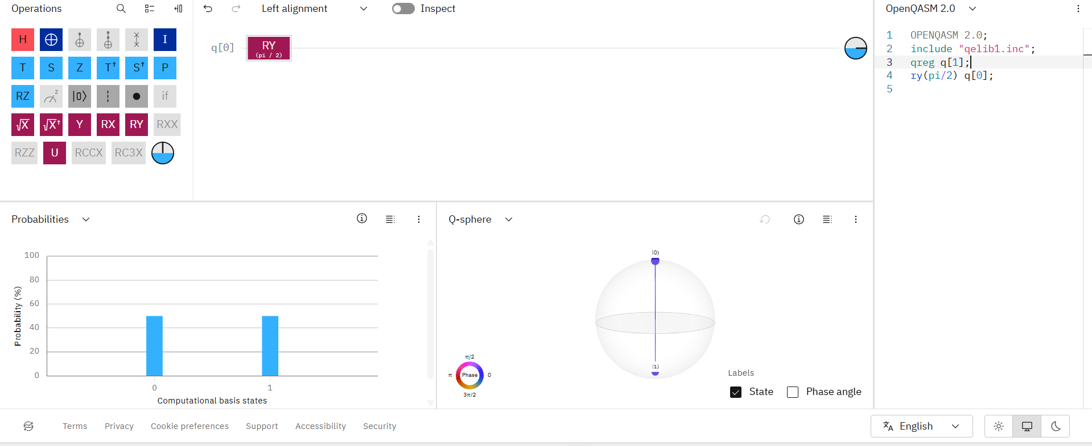 OPENQASM 2.0;
include "qelib1.inc";
qreg q[1];
ry(pi/2) q[0];

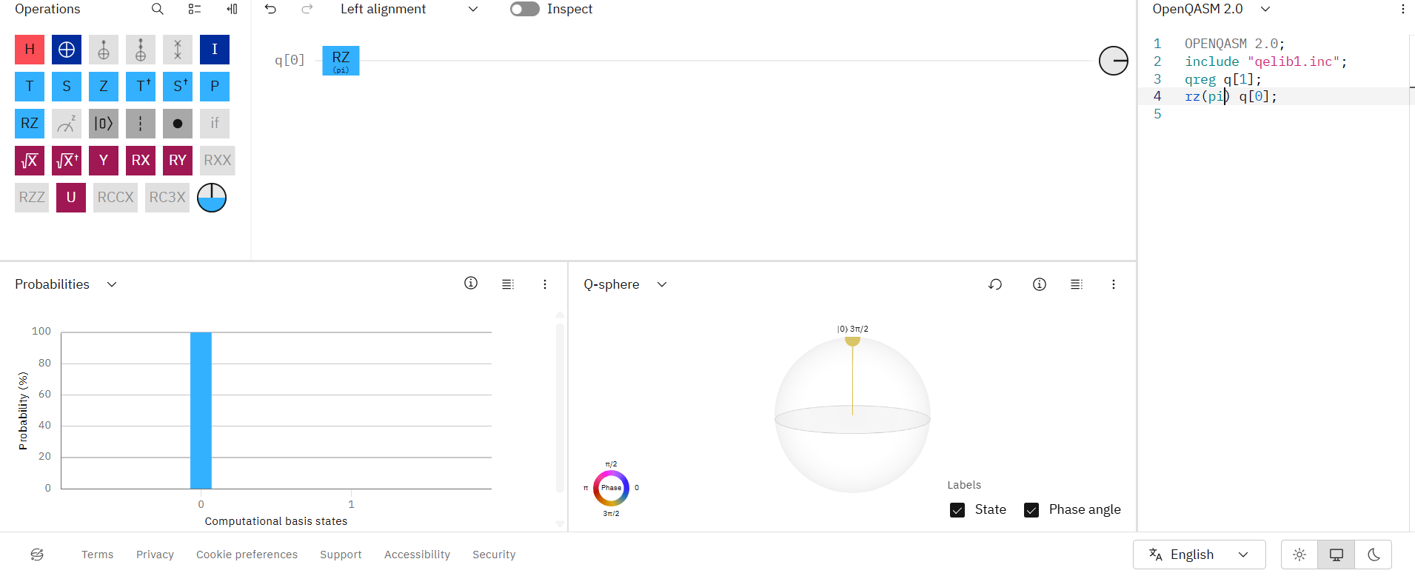 OPENQASM 2.0;
include "qelib1.inc";
qreg q[1];
rz(pi) q[0];

Experiment 6:
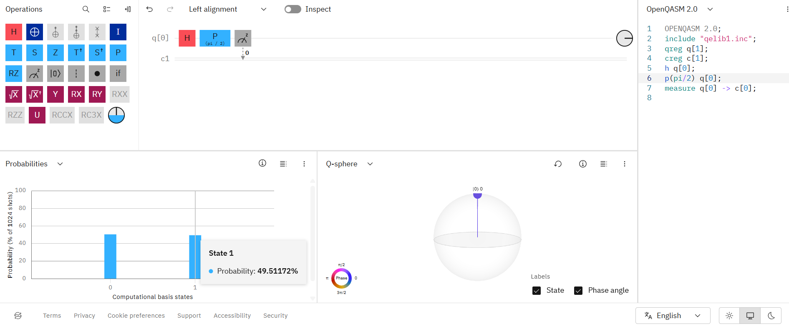 OPENQASM 2.0;
include "qelib1.inc";
qreg q[1];
creg c[1];
h q[0];
p(pi/2) q[0];
measure q[0] -> c[0];

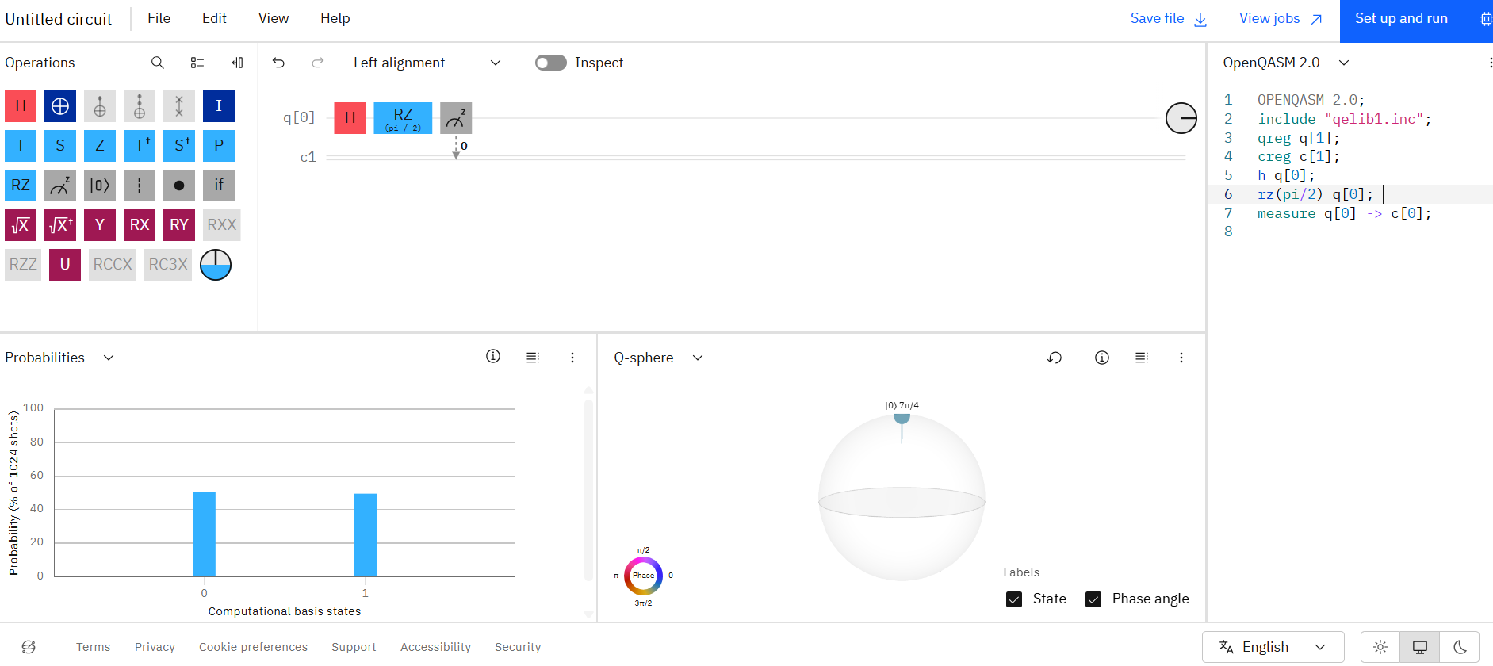
OPENQASM 2.0;
include "qelib1.inc";
qreg q[1];
creg c[1];
h q[0];
rz(pi/2) q[0];
measure q[0] -> c[0];

Experiment 7:
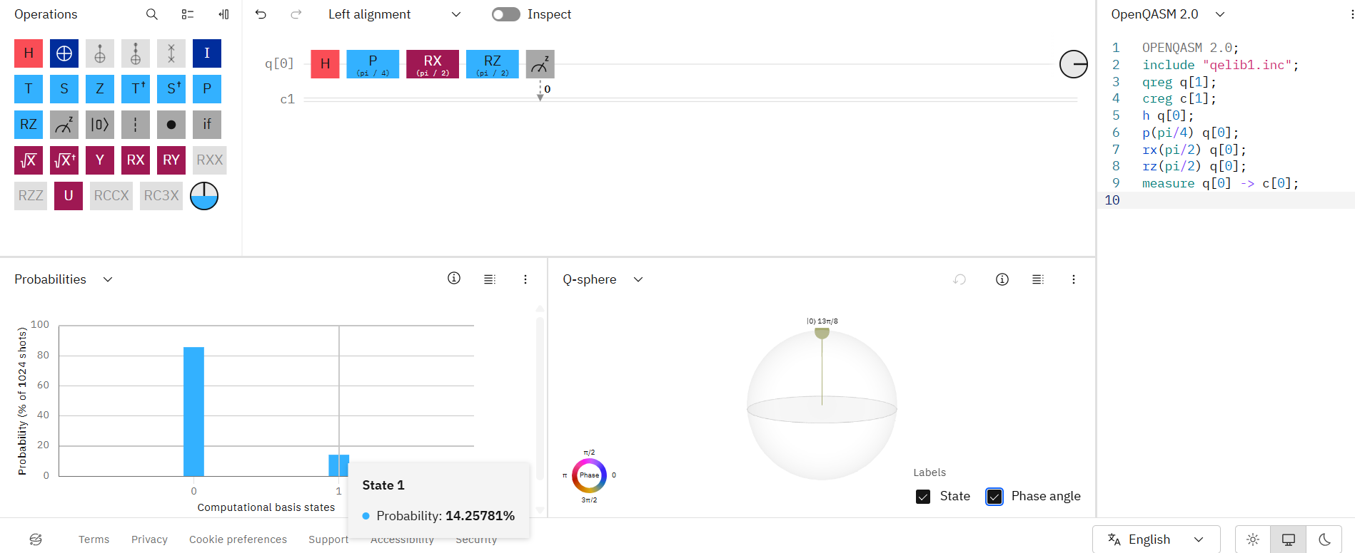

OPENQASM 2.0;
include "qelib1.inc";
qreg q[1];
creg c[1];
h q[0];
p(pi/4) q[0];
rx(pi/2) q[0];
rz(pi/2) q[0];
measure q[0] -> c[0];

Experiment 8:
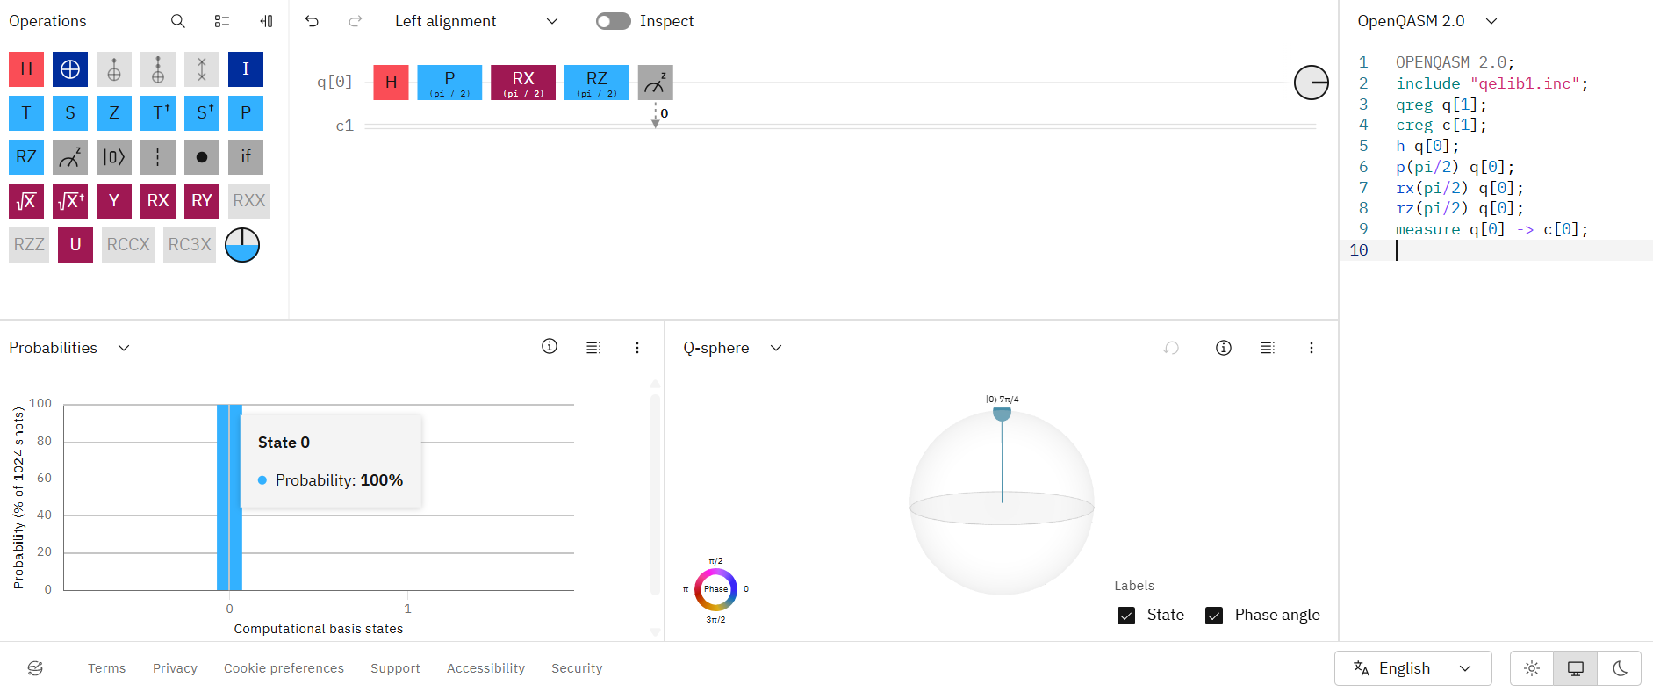

OPENQASM 2.0;
include "qelib1.inc";
qreg q[1];
creg c[1];
h q[0];
p(pi/2) q[0];
rx(pi/2) q[0];
rz(pi/2) q[0];
measure q[0] -> c[0];

